**Stage 1 - Load up on guns, bring your friends**

**COURSE DESIGNER:** Ike Starnes

|  |
| --- |
| **SCORING:** Comstock 28 rounds.  **TARGETS:** 14 cardboard targets  **SCORED HITS: 2** Best hits per carboard will be scored. |

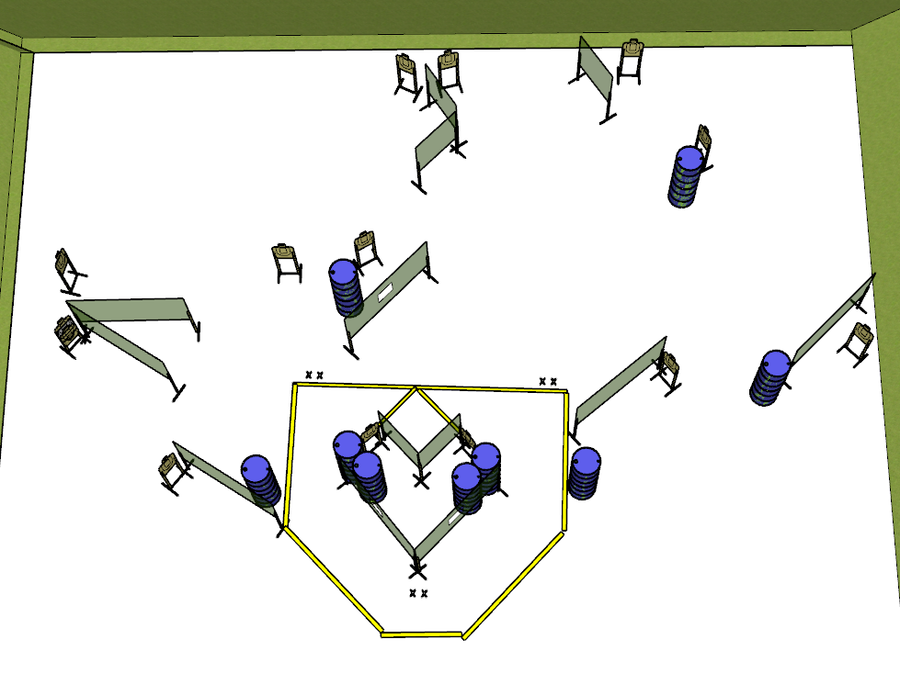

**Written Stage Briefing:**

**Stage 1 – Load up on guns, bring your friends -** is a 28 round, 140 point, Comstock Course. There are 14 cardboard targets. The best 2 hits per cardboard target will be scored.

**Start position** Both feet on the rear Shooting Sports Innovations Xs.

**Handgun: Loaded and holstered, both hands touching wall**

**PCC: Loaded, stock touching belt, muzzle touching wall**

On the audible start signal, engage targets from within the shooting area.

**USPSA / NROI Range Commands:**

* Make Ready
* Are you ready?
* Standby
* If finished, unload and show clear.
* If clear, hammer down and holster
* Range is clear

**Setup Notes:**

18 Single Wall Stands

4 Double Wall Stands

5 Full Walls

3 Port Walls

5 Half Walls

14 Target stands / 28 target sticks

3 Starting Xs

18+ barrels

